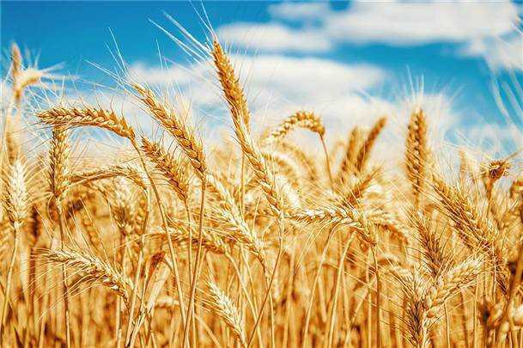 **FIRST FRUIT SOWING SCHEDULE**

**2024/5784-5785**

**Pey-Dalet/Pey-Hey Year of The Open Door!**

**The Year To Behold!**

**Listed below is the 2024/5784-5785 First Fruit Sowing Schedule based on the 5784/85 feasts. See each date for instruction. *First Fruit is *not commanded* for New Testament Believers!** Participation is a matter of *honoring* God’s system of increase, given to Israel to be practiced perpetually, to yield a maximum harvest**.**

**REMINDER: THIS IS PRACTICED IN HONOR! ALL DATES ARE ADJUSTABLE *BASE ON YOUR PERSONAL PAY DAYS!* SOW BY GRACE AND NOT BY LAW! EVERY SEED YIELDS HARVEST IN YOUR LIFE!**

|  |  |
| --- | --- |
| **DATE** | **FIRST-FRUIT SEED** |
| 1. March 31st | *Resurrection/Easter Sunday – Seed of Choice |
| 1. April 9th /1 Nisan | Store seed of choice |
| 1. **April 22-30, 2024/**   **14 Nisan 5784** | **Sow the Stored seed from April 9th**  #1 |
| 1. **April 23, 2024/**   **15 Nisan 5784** | **Passover-Feast of Unleavened Bread (Pesach) Nisan16 {First Fruits}**  **Store** seed of choice |
| 1. May 19th | *Pentecost Seed – Seed of Choice  #2 |
| 1. **June 11-13, 2024/ 5-7 (6) Sivan 5784** | **Pentecost (Shavuot)**  **Sow** the **Stored** seed from **April 23rd** |
| 1. **October 2, 2024/ October 6th /1/2 Tishri 5785** | **Feast of Trumpets (Rosh Hashanah)**  **Sow** seed of choice |
| 1. **October 11, 2024/ 10 Tishri 5785** | **Day of Atonement (Yom Kippur)**  **Sow** SET SEED of **$50**  #3 |
| 1. **October 16, 2024 (week)/ 15-23 Tishri** **5785** | **Feast of Tabernacles (Sukkot)**  **Sow** seed of choice |

**FIRST FRUIT SOWING SCHEDULE**

**2024/5784-5785**

**Pey-Dalet/Pey-Hey Year of The Open Door! The Year To Behold!**

**Listed below is the 2024/5784-5785 First Fruit Sowing Schedule based on the 5784/85 feasts. See each date for instruction. *First Fruit is *not commanded* for New Testament Believers!** Participation is a matter of *honoring* God’s system of increase, given to Israel to be practiced perpetually, to yield a maximum harvest**.**

**REMINDER: THIS IS PRACTICED IN HONOR! ALL DATES ARE ADJUSTABLE *BASE ON YOUR PERSONAL PAY DAYS!* SOW BY GRACE AND NOT BY LAW! EVERY SEED YIELDS HARVEST IN YOUR LIFE!**

|  |  |
| --- | --- |
| **RESURRECTION SUNDAY/EASTER – MARCH 31ST** | **Freewill Seed of your choosing!** |

1. ***Morning Worship* (April 9, 2024)/1 Nisan 5784 - Store seed of choice - New Cycle Start Day*!***

Any income received **prior to** the *first ten days*, take a portion, of your choosing, and set it aside. That is your first fruits of the NEW year *Proverbs 3:9-10, Nehemiah 10:35-39*. This is of the old corn, but it is also part of the first fruits of the year ***Joshua 5:10-12****, *Leviticus 23:9-14 (v11)*.

1. ***Evening of* April 22-30, 2024/14 Nisan 5784 - Sow seed of choice from April 9th.**

Old Corn Offering - Sow from last income that you received **BEFORE April 9, 2024/I Nisan/Adar 5784**

1. **April 23, 2024/15 Nisan 5784/16 Nisan – First-Fruits - Store** seed of choice

**[Feast Offering!]** Income received after the first ten days, **but on/before April 23, 2024**, set a portion of your choosing, (write down something that you want to change for the good, and place in envelope), and **hold on to it until the Day of** **Pentecost (Shavuot).** This is a **Passover-Feast of Unleavened Bread (Pesach**) seed and part of the new harvest *\*Exodus 12:1-7, *Leviticus 23:4-8*. Take communion in your home, and do a fast of eating no leavened bread **April 22-30, 2024,** in honor of the Feast of Unleavened Bread *Exodus 12:8-15*.

#1

|  |  |
| --- | --- |
| **PENTECOST SEED – SOWN SUNDAY, MAY 19th.** | **Freewill Seed of your choosing!** |

1. **Tuesday-Thursday,** **June 11-13, 2024/5-7 (6) Sivan 5783 – Sow** the **Stored** seed from **April 23rd**

**[Feast Offering!]** Coming up to **June 12, 2024/6 Sivan 5785, (Pentecost- 50 days after Pesach)** *(frequently Passover),*give an *offering of your choosing* *along with the first fruit offering* (that you place in envelope @ Passover) to the leader of the house **to be waived for a waive offering** *Leviticus 23:15-22 (v.20)*, in honor of the **Feast of Weeks (Shavout)**. Any change to your circumstances that you wrote on your piece of paper for the *wave offering*, *need to be reported to your leader for your wholeness* *Luke 17:11-19.*

#2

1. ***Evening of* Wednesday/October 2, 2024/Sunday – October 6th** **/1/2 Tishri 5785 - Sow** seed of choice. **[High Holy Days!] On Wednesday-Friday, October, 2024/1/2 Tishri 5785,** plan to rest and if possible, take the day off on the **Feast of Trumpets (Rosh Hashanah)** and give an offering of choice. *Leviticus 23:23-25*.

NY 5785

1. ***Evening of* Friday, October 11, 2024/10 Tishri 5785 – Sow** SET SEED of **$50. Day of Atonement (Yom Kippur)**, which is **Saturday, October 12, 2024/10 Tishri 5785**. Each senior congregation leader seeks God about an equal amount that EVERY MEMBER of their congregation that is above 20 years old can give as an offering, as well as plan for everyone possible to do a complete fast on that day *Leviticus 23:26-32, Matthew 6:16-18, *Exodus 30:11-15*.
   1. ***Evening of* Wednesday,** **October 16, 2024 (week)/15-23 Tishri** **5785 - Sow** seed of choice. **[Feast Offering!]** And for the last, and one of the most important feasts, **the Feast of Tabernacles (Sukkot)**, **October 17-25/15-23 Tishri**, plan to give an offering of your choosing ***Leviticus 23:33-44 (v.37-38), *Zechariah 14:16-19 (v.17-18).***

#3

**\*Civil New Year(s)- October 2, 2024/1 Tishri 5785/*Ecclesiastical New Year – March 30, 2025/1 Nisan 5785**